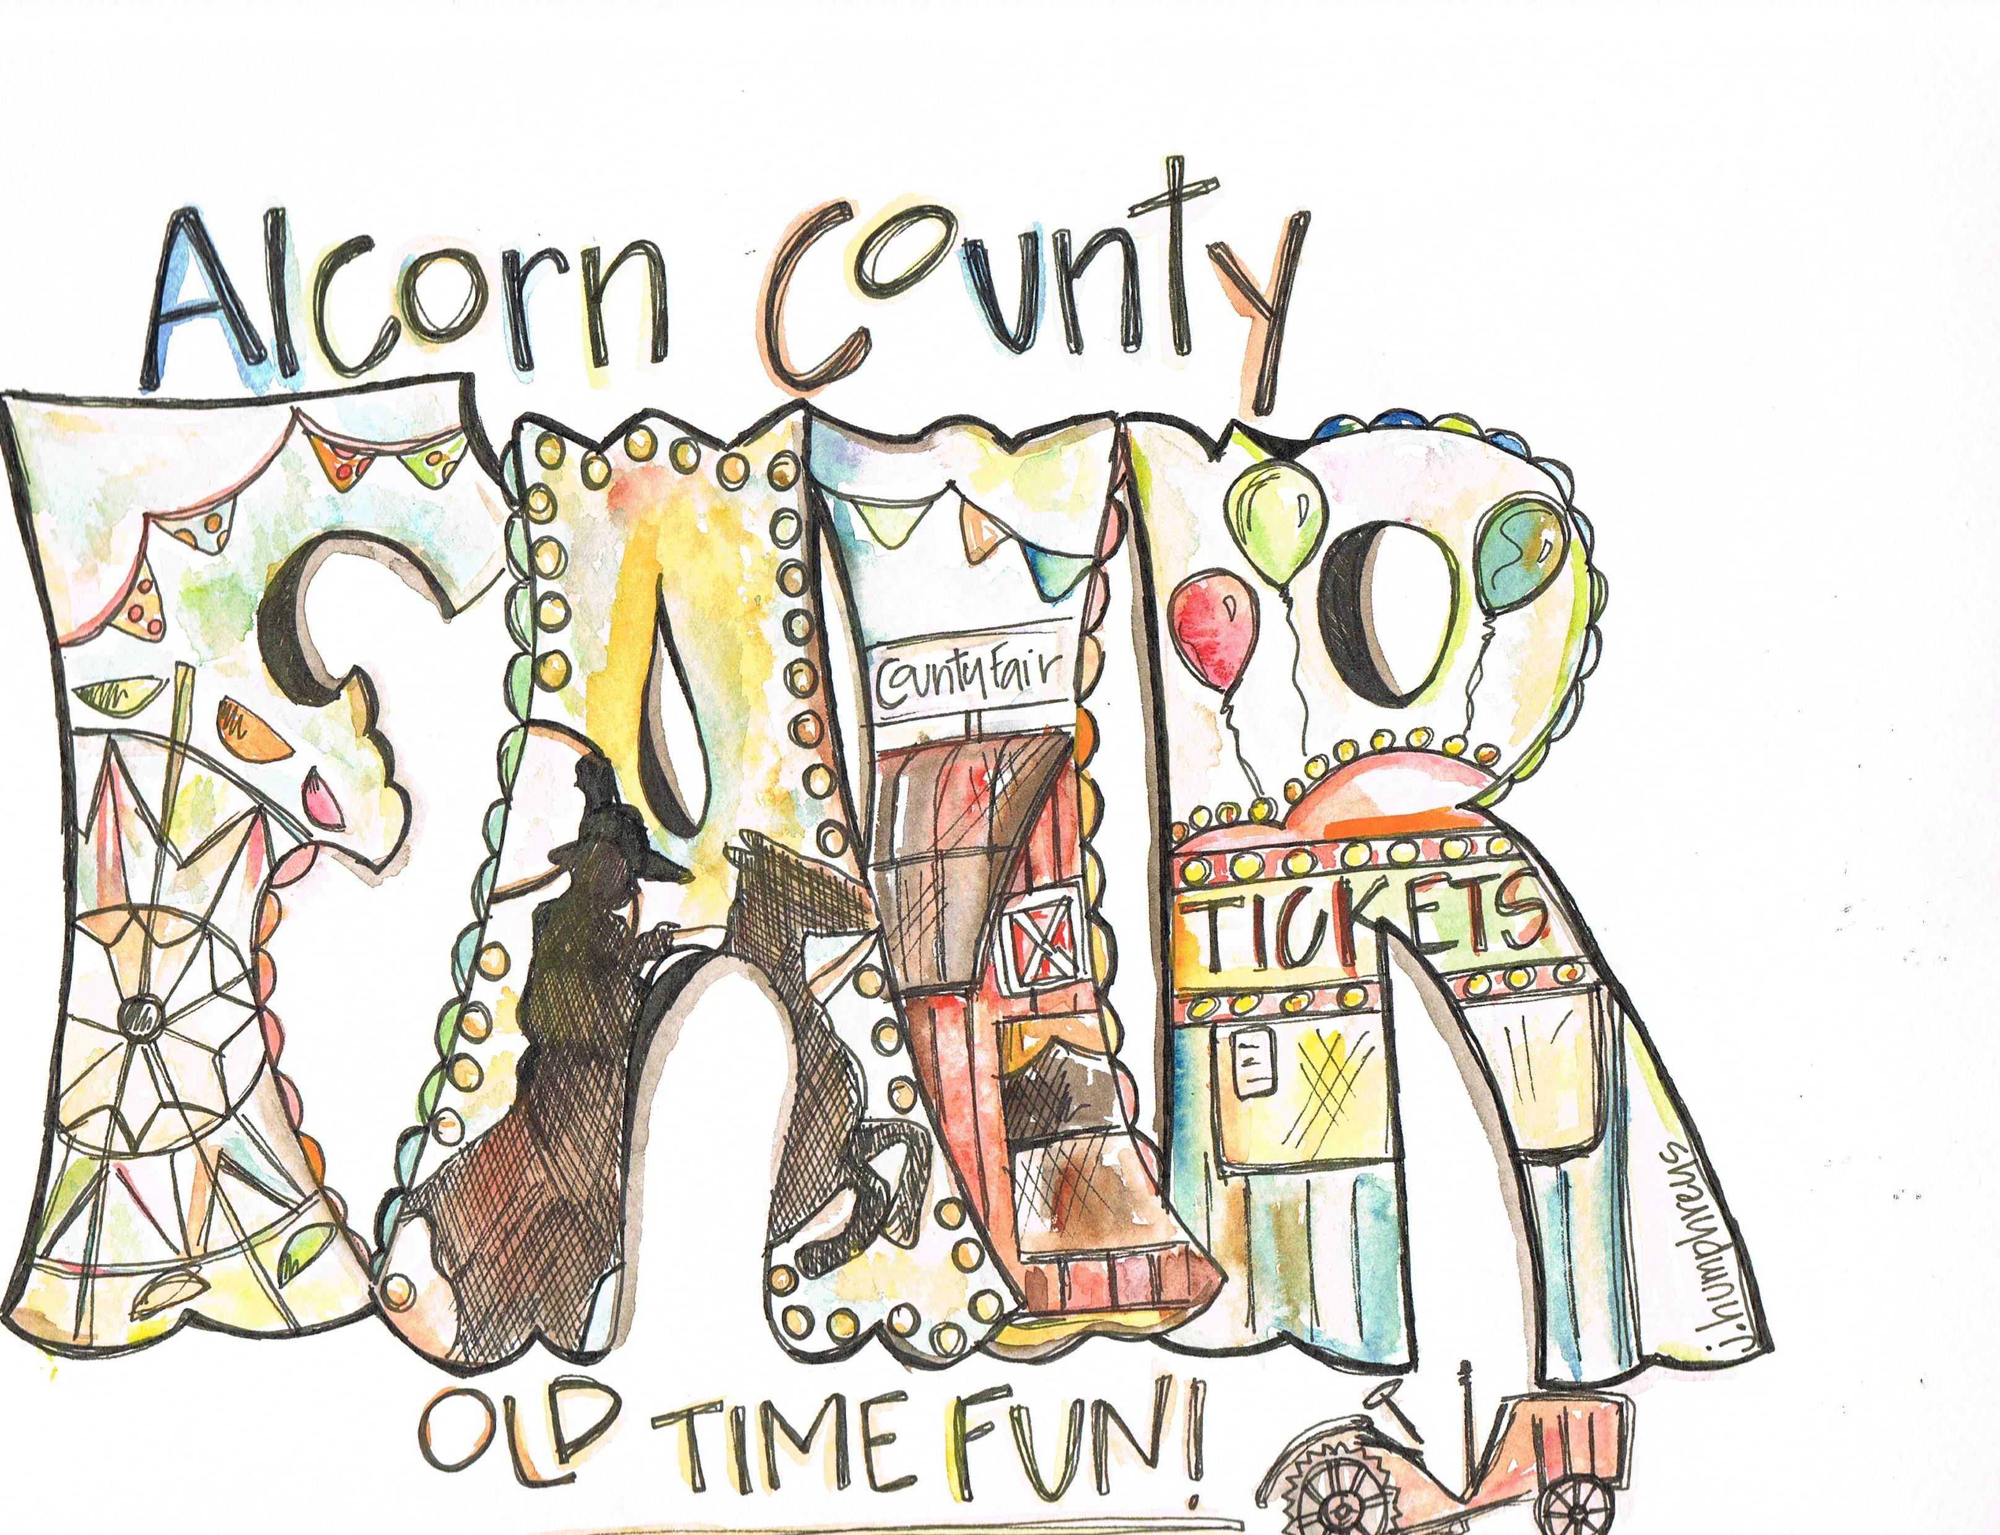

Quilt Show Entry Form
This form may be reproduced for multiple entries.
Exhibitor Name: Quilt Name:
Street: City: State: Zip: Phone: ( )
Cell( ) Email:

Entry Category

Professional Amateur

Large Professional (min. 72” x 50”) Large Quilts (min 72” x 50”)

Small Professional Small

Wall Quilt Wall Quilt

Old Quilt Old Quilt

New Quilt New Quilt

Quilt Perimeter: Length: Width:

Made By: Owned By:

A few words about your entry:

Quilt for sale? Yes No Asking Price: $

I agree to release the respective agents and members of the Alcorn County Fair from all liability for any loss, damage, theft, injury or destruction to any article entered by me in the ACF Quilt Show September 13-17, 2011. I understand that I bear and agree to assume the risk of loss to my property and that it is up to me to properly insure my property against any or all risks of loss.

Exhibitor Signature: Date:

