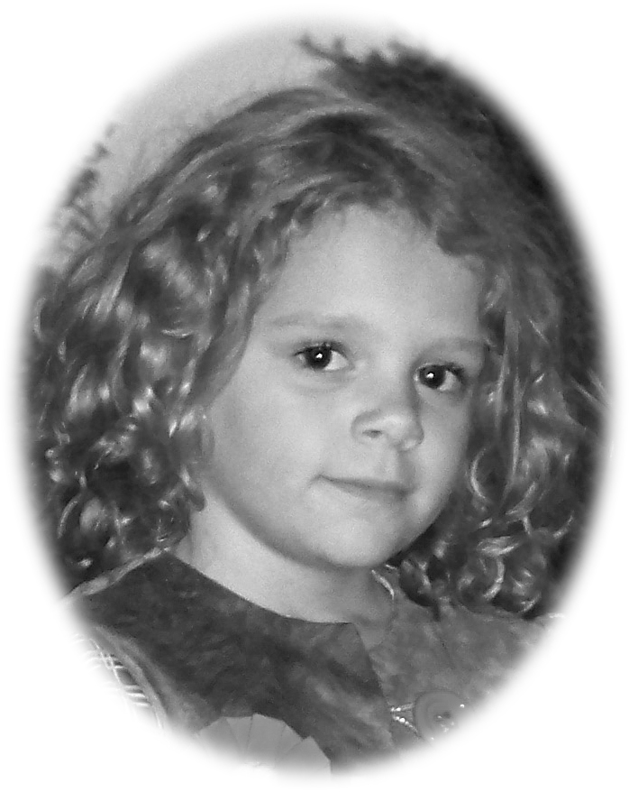
Happy 8th Birthday

Sara M.

Filemyr
2010

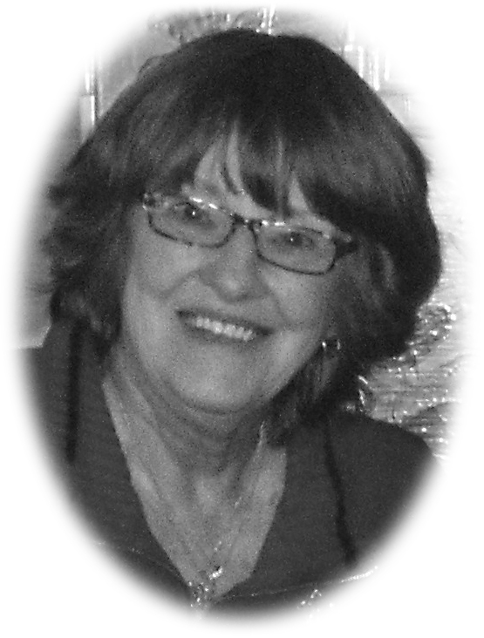

Made by her
Great Grandmother

Jeannie M Smith
Bethlehem, GA

Happy Birthday


Brittany L.

Lynn
2010

Made by her

“MaMaw”

Jeannie M Smith
Bethlehem, GA

