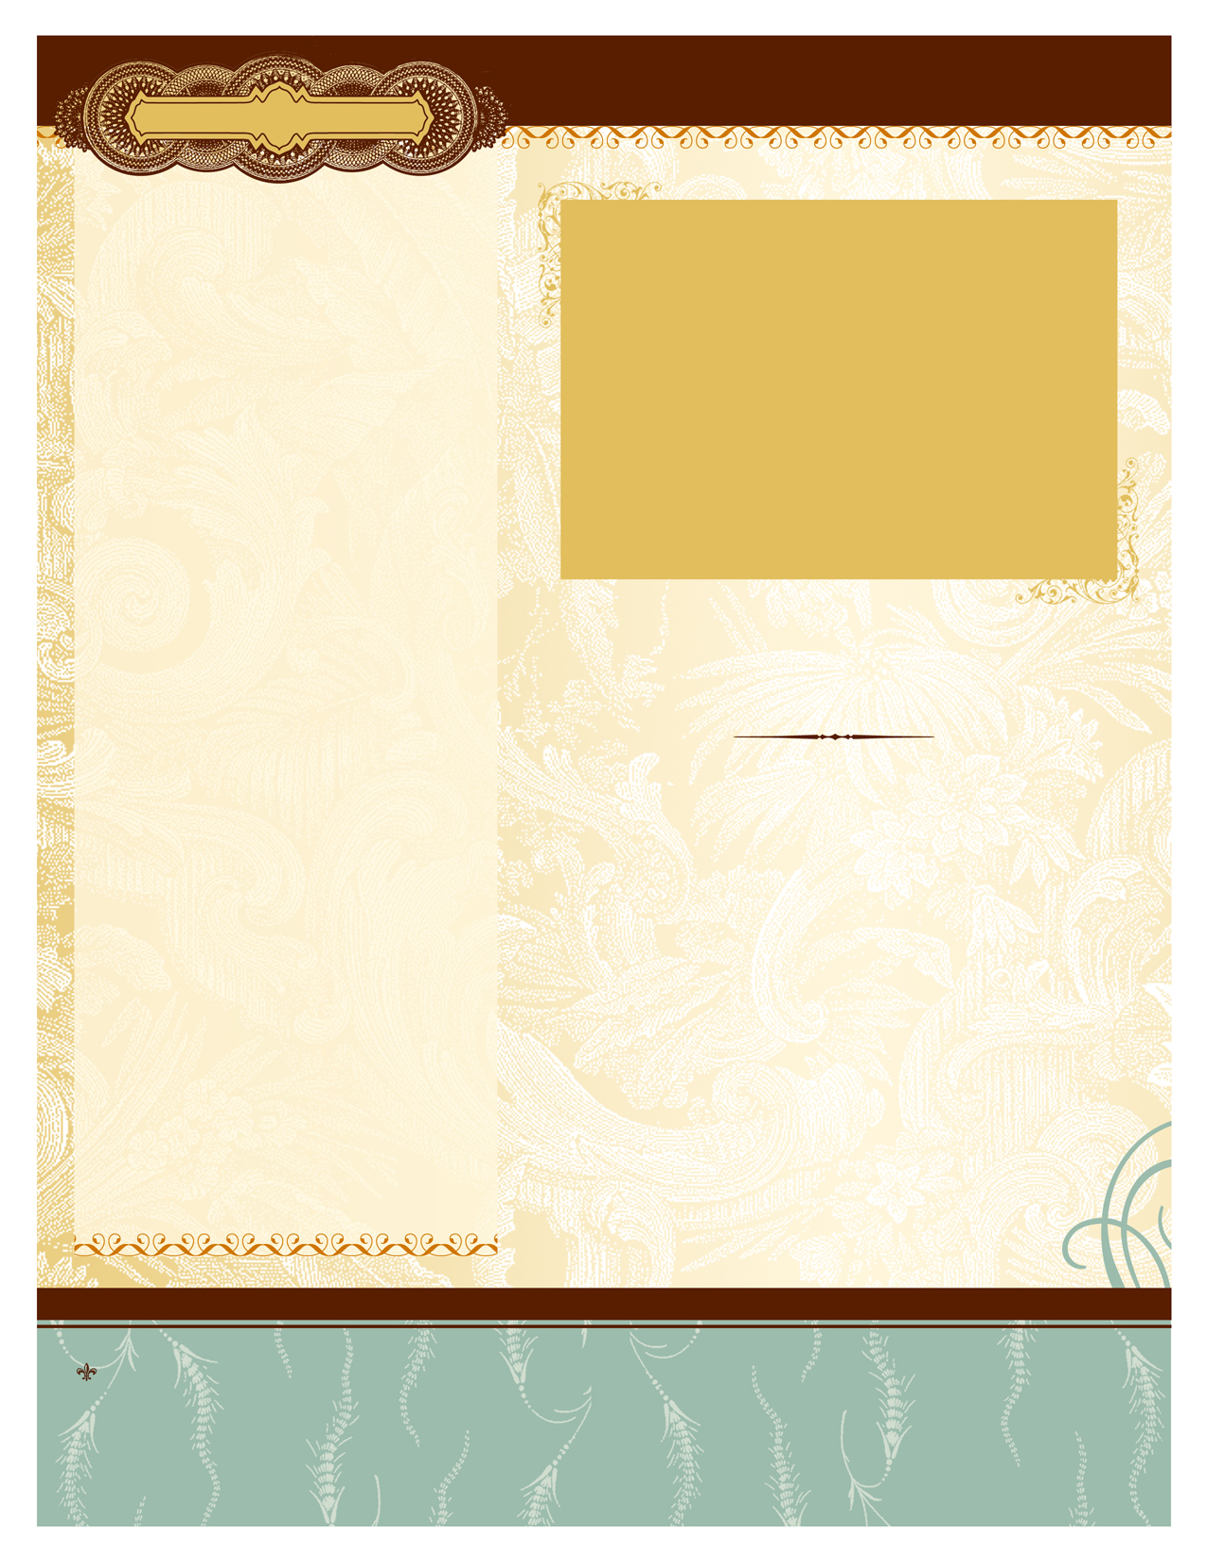
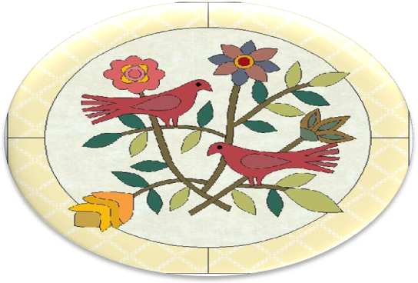

Fabric

Manufacturer / Collection | Fabric Name/# | Yardage | Cost

Quilt Record
Name:
Made By:
Dimensions:
Date Started:
Date Completed:
Where:
Given To:
Occasion:

Blocks
Name | Size

Notes, Suggestions, Lessons Learned.

