http://www.barbarabrackman.com/faqs5.aspx

Clues in the Calico
QUILT DETECTIVE EMAIL NEWSLETTER
Every year or two I offer a digital newsletter in my Quilt Detective series. In 2010 the topic is "Prints, Colors & Dyes". Quilt historians and collectors will want this update to my Clues in the Calico book. In a weekly PDF delivered by email you'll explore fabric from 1780 to 1950. Each week you'll receive the latest information about antique dyes and prints with color photos and links to online quilts.
Computer Requirements:
. Email with 1 megabyte downloading capability
. Adobe Acrobat PDF capability
Cost: $25 for 25 weekly issues
Pay by sending a check for that amount to
Barbara Brackman
3115 W 6th St. #C-237
Lawrence, KS 66049
Or use PayPal. Send $25 to my email address: BBrackman@Sunflower.com. However you pay---be sure to send your email address!
Click here for more information: Quilt Detective Information.
And click here for a free sample of the first issue. Sample Issue.

Bookmark this page for information about dating antique quilts.
Below you'll find information for Quilt Detectives new at analyzing clues. More advanced students will find detailed information by clicking on files labeled Clues in Techniques. These include advanced information updating my 1989 book Clues in the Calico. The files are a multi-part newsletter I wrote in 2005. The material is more up-to-date and more comprehensive than in the original book.
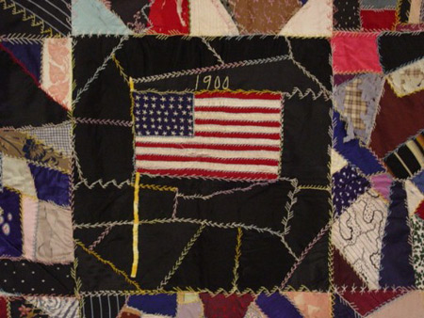
* A Dozen Clues for Beginning Quilt Detectives
Myths About Old Quilts
01 Clues in Techniques: QUILTING
02 Clues in Techniques: PIECING
03 Clues in Techniques: APPLIQUE
04 Clues in Techniques: EMBROIDERY
05 Clues in Techniques: FOUNDATION PATCHWORK
06 Clues in Techniques: TIED QUILTS & UNQUILTED TOPS
07 Clues in Techniques: INSCRIPTIONS
08 Clues in Techniques: NOVELTY TECHNIQUES
09 Clues in Techniques: EDGING
10 Clues in Techniques: BACKING & BATTING
11 Clues in Techniques: INDEX
* A Dozen Clues for Beginning Quilt Detectives
If you are new to quilt dating you'll want to memorize these clues as they are the first things to learn about how quilt style, fabrics and patterns help you date an antique quilt.
1. Crazy quilts date from 1880 or later. Some will have earlier dates, but these commemorate births, marriages, etc. The fancy linear stitching covering the seams appears in other patterns too and it's a good clue to "after 1880."
2. Friendship quilts, album quilts and other quilts with signature blocks date from 1840 or later. Because they are often dated it's been easy to determine when the fad began.
3. Sunbonnet Sue and the Double Wedding Ring are twentieth-century patterns. Wedding Rings begin in the 1920s and Sunbonnet Sue and Dutch Boy quilts go back to about 1910, although the vast majority were made after 1930.
4. Black dyes for cotton were difficult to obtain before 1890 or so, so if you see a fabric with a large area or a background of true black it probably dates to after 1890.
5. Tied comforters (especially those with ties showing on the top) tend to date to after 1875.
6. Bias binding is rare before 1900 and most common after 1925. Prairie Points (triangles inserted into the edge) are also a good edging clue to a date after 1925.
7. Stuffed and corded quilting died out after 1865 with a few exceptions.
8. Antique quilts with a red and green on white color scheme are likely to be from 1840 to 1900.
9. Patterns constructed using foundation patchwork or pressed patchwork, such as log cabins, string quilts or pineapples, tend to date after 1860 and most likely after 1880. Log cabin quilts were the first to be pieced on foundations and they date from the early 1860s.
10. Reddish-brown cotton prints, known as madder-style prints, are a good clue to a quilt made before 1900. Red-browns became unfashionable about then.
11. Maroon or wine-colored cotton prints with a white or black figure on the dark red background are good clues to a date between 1890 and 1925, as is the grayed blue known as cadet blue and the black on white prints known as mourning prints. These red, blue and black prints were very popular with quilters in those years.
12. Plain pastel cottons like peach, lavender and Nile green are most likely to be post-World War I. Plain pinks and yellows are found in earlier quilt but they are also likely to be 1920 or later, especially when combined with other plain pastels.

Myths About Old Quilts
I first published these myths in 1987 before anyone had ever heard of the Underground Railroad code. The myths have changed but below are a few we still hear.
Myth # 1. Quilts were used as code on the Underground Railroad.
Fact. This is a relatively new myth and there is no historical evidence that quilts were used for signals, codes or anything but warmth by escapees and their helpers. For more click here to see my page on the Underground Railroad. UGRR Quilts.
Myth # 2. Quilts are born of necessity, the work of poor people or pioneers.
Fact: Quilts require an abundance of fabric rather than scarcity. When fabric was hard-to-find or relatively expensive, quilts were the bedding of the well-to-do. Women living on the frontier generally brought quilts with them and didn't begin making them again until they had access to a good deal of inexpensive cotton.
Myth # 3. Homespun cotton was a common quilt backing.
Fact: Those rather coarse cotton quilt backs seen on early quilt are an inexpensive factory-spun and factory-woven cotton that people used to call domestic cloth. In America most homespun yarn was wool or linen. Spinning cotton by hand was rare and many homewoven fabrics were made of homespun wool and factory-spun cotton yarns.
Myth # 4. If you hold a quilt up to the light you may see cotton seeds.
Fact: A cotton seed is the size of a navy bean. The dark spots you see are cotton refuse from the hull, stems and leaves and possibly ground up seeds (seeds might leave an oily residue).
Myth # 5. Cotton refuse means the quilt predates the cotton gin (1792).
Fact: People who lived in cotton producing areas made their own batting up through the 1940s without benefit of a mechanical cotton gin. But even manufactured batting has refuse. Since the mid 19th century mills produced clean cotton batts sold at a higher price than substandard cotton bats. Cotton refuse means the batting was a cheaper batt or possibly a homemade batting.
Myth # 6. The Crazy Quilt is the earliest type of quilt.
Fact: The Crazy Quilt is as old as the telephone. Although those random pieces look rather amoeba-like, one cannot apply Darwinian theories of evolution to quilts. The earliest patchwork patterns were of squares and triangles pieced into pinwheels, stars, nine patches, etc.
Myth #7 To date a family quilt, count 20 years for each generation.
Fact: Women bear children for over 30 years. Some make quilts from before they are 5 till after they are 95. To date a quilt look at fabric, style, technique and family history.
Myth #8. Americans everywhere were making the same quilts at the same time.
Fact: Quilt project research has shown us that styles, patterns and even quiltmaking itself was regional in nineteenth-century America.
Myth #9. The cruder the quilt the older it is.
Fact: Crude quilts are more likely to date from hard times than old times. Bigger pieces mean less waste in the seams and tied bedding requires less time than quilting. Standards of craftsmanship change over time too with low points following high points.

01 Clues in Techniques: QUILTING
Click here to read the text of my 2005 newsletter about how clues in quilting can help you date and identify antique quilts. QUILTING.
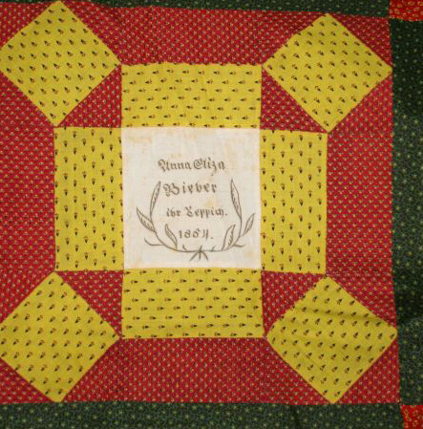
02 Clues in Techniques: PIECING
Click here to read Part 2, how clues in the piecing techniques can help you date and identify antique quilts: PIECING.

03 Clues in Techniques: APPLIQUE
Click here to read Part 3, how clues in the applique techniques can help you date and identify antique quilts: APPLIQUE.

04 Clues in Techniques: EMBROIDERY
Click here to read Part 4, how clues in decorative embroidery can help you date and identify antique quilts: EMBROIDERY.
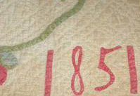
05 Clues in Techniques: FOUNDATION PATCHWORK
Click here to read Part 5, how clues in foundation piecing can help you date and identify antique quilts: FOUNDATION PATCHWORK.

06 Clues in Techniques: TIED QUILTS & UNQUILTED TOPS
Click here to read Part 6, how clues in tied comforters, summer spreads and other alternative quilting styles can help you date and identify antique quilts: TIED COMFORTERS.

07 Clues in Techniques: INSCRIPTIONS
Click here to read Part 7, how clues in inscriptions can help you date and identify antique quilts: INSCRIPTIONS.
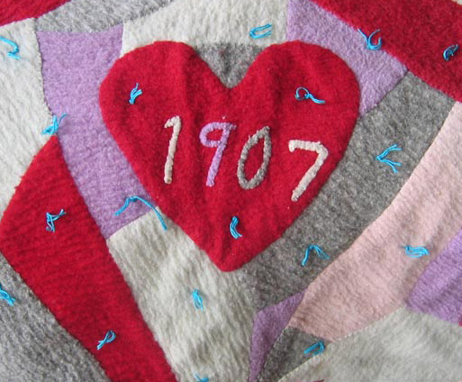
08 Clues in Techniques: NOVELTY TECHNIQUES
Click here to read Part 8, how clues in novelty techniques such as folding, gathering and painting can help you date and identify antique quilts: NOVELTY TECHNIQUES.

09 Clues in Techniques: EDGING
Click here to read Part 9, how clues in the quilt's edging and binding can help you date and identify antique quilts: EDGING.

10 Clues in Techniques: BACKING & BATTING
Click here to read Part 10, how clues in backings and battings can help you date and identify antique quilts: BACKING & BATTING.
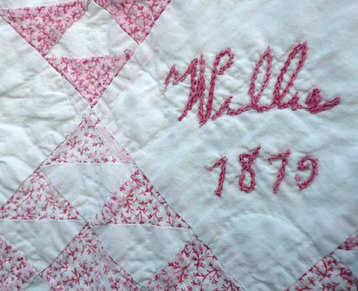
11 Clues in Techniques: INDEX
Click here to see the Index to the ten parts (43 weekly issues): INDEX.

