SETTING QUILTS ON POINT - Determining your setting triangles

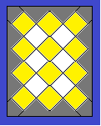

My technique allows your pieced blocks to “float” away from the seam of the borders, helping to prevent losing sharp points in the seam allowance. The setting triangles are cut larger than you will need, which will give you plenty of allowance to square up your quilt before adding borders. If there is more “float” than you’d like, just trim it away after the top is assembled. In my opinion, on-point quilts are much more stable, less likely to stretch and wave on their edges, because you can use this technique. They are also more eye appealing because, using this float technique, they do not “confine” the block.

SIDE SETTING TRIANGLES:
1. 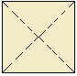 This is the square which will make the triangles for the SIDES of your quilt.

2. Determine the size of this square by measuring the diagonal of a pieced block in your quilt and
adding 3 inches.**

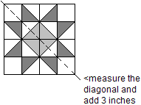

Need a square bigger than you’ve ever cut before? See below.

HINT: **Because this measurement may be a larger square than any ruler you have, try folding the yardage into a large triangle from the corner and then cutting the two straight edges and opening to form a square.
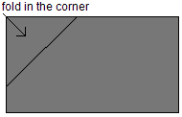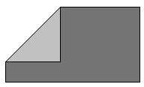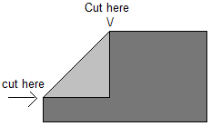

3. Cut this resulting square through both diagonals to create 4 triangles (indicated by the dashed lines shown in step 1.) Each square will produce 4 side triangles, so determine how many squares you need by the number of blocks in your quilt.

4. The long edge of this triangle will be on the straight grain of the fabric and this will help stabilize the sides of your quilt.

5. The short edges of the triangles will be on the bias edge of the fabric and will be stabilized by the straight grain of the block next to it.**

CORNER SETTING TRIANGLES
1. 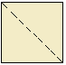 This square will produce the corner triangles for your quilt; you will need TWO squares to make the four corner triangles.

2. Determine the size of this square by measuring a pieced block in your quilt along one outside edge of a pieced block and ADDING 3 inches.
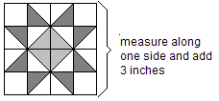

3. Cut this square through one diagonal to create TWO triangles (indicated by dashed lines in step 1).

4. The short edges of this triangle will be on the straight grain of the fabric, which will help stabilize the corners and sides of your quilt.
The long edge of the triangles will be on the bias edge of the fabric, which will be stabilized by the straight grain of the block next to it.

************************************************************

SEWING IT ALL TOGETHER:

On point quilts are sewn together in diagonal rows starting with one corner, with the setting triangles attached to the ends of the appropriate rows.

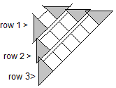and so forth.

After you have added the setting triangles to one row, trim off the overhanging tips of the triangles, parallel to the side of the pieced block so you can sew the next row.

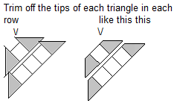

Sew the rows together.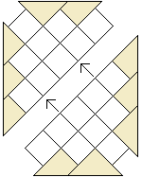 Sew on the corner triangles last. 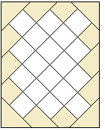

Your edges will be ragged-looking as the setting triangles are yet to be trimmed. The extra size of the setting triangles have given you plenty of room to square up your quilt sides without losing your points. When you trim, if you will let your blocks “float” a little from the edge of the quilt, that “float” will give your quilt a more skilled, “masterful” look.

Press and square up the top being sure to leave the same amount of “float” on all sides of the quilt.

